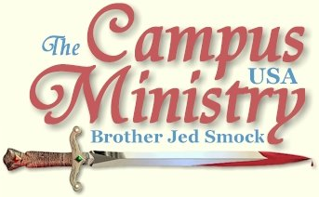
brojed@aol.com
brojed.org
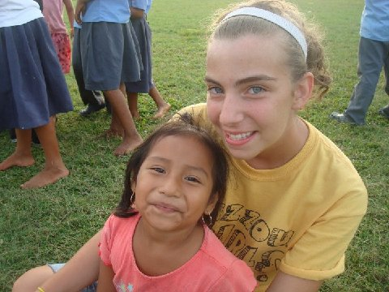

In June, Priscilla was a part of a seven day mission trip to Belize to minister among Mayan peoples. She went with her church high school youth group, who ministered under the umbrella of an evangelical mission group called Praying Pelicans. Priscilla spent the year praying, planning and raising money for her trip. The youth did a combination of building projects and children's ministry. Priscilla was really impacted by the opportunity. Below is a testimony that she gave in our church on the 4th of July. I have also included some pictures from the trip:

“A smile is worth a thousand words. This sentence was never real to me till my trip to Belize. I’m not even sure anymore how many real smiles I had seen before this trip. Each afternoon we would go out to an open field and play games and different sports with the kids in our area. Every one of those children had a real smile on their face. They were constantly smiling, and I’m kind of embarrassed to say it, but the first few days of our trip I wasn’t sure why they were so happy. I mean they have pretty hard lives. Then I thought, ‘it’s me, and my church, and all that were doing for these kids. I’m the reason they’re so happy.”
I didn’t understand the real reason until a little girl who I had been playing with said to me, ‘I love you, and I love Jesus.’ It hit me: these kids weren’t happy because I had come all the way from Belize to play tag. It was all God’s doing. They were happy because they were surrounded by God. They had God’s Spirit in them, I could see it through their smiles. For the first time in my life I feel like I saw God’s face. It was in the countenance of those children.
It sounds kind of cliché, but I think one of the best ways to show people the love of Christ, is to show them how joyful you are in Him.
I feel like I grew up and learned a lot on this trip. I know longer have to scream to my dad to come and kill bugs anymore. Seeing how much worse they are in Belize, I think I can handle ours here in Missouri. I also learned that some of my “big” problems aren’t really that big of a deal at all. When I went on this trip I thought I wouldn’t be able to survive without my phone, Ipod, and Facebook. But as you can see I did survive.
I was so welcome in Belize I felt like I was part of their family. I would like to thank everyone that contributed to this mission. My trip challenged me in more ways than I could have imagined. I will never be the same again, and I hope I never forget anything about this experience.”
Priscilla Smock
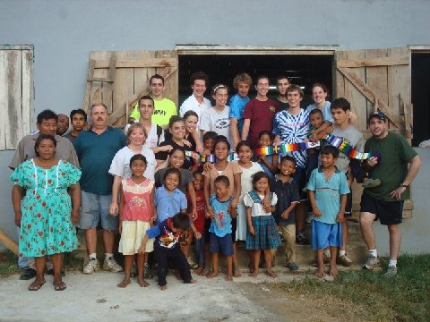
The Mayan pastor and his wife are on the far left.

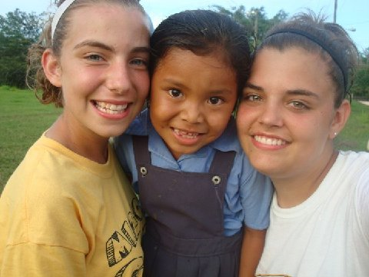

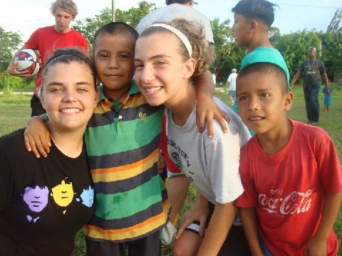

Priscilla turned 16 on the 4th of July and is a Junior in home school High School. Last spring she played Sister Sophia in Sound of Music and this summer she has a lead role, Chava, in the musical Fiddler on the Roof. She is party of a community theatre.

When she finishes high school she wants to do mission work the first year...maybe in the Philippines with Bro. Mitch. Pray for her.

Brother Jed and Martha are on their way home from the Virginia Beach trip...a report will be coming.

In Christ,
Sister Cindy

